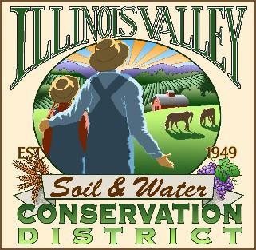
Illinois Valley Soil and Water Conservation District
331 E Cottage Park Dr Suite 1B - P.O. Box 352
Cave Junction, OR 97523 Phone: 541-592-3731

Monthly Board Meeting Agenda November 21, 2024- SWCD Office/ZOOM
(Preceded by Annual Meeting)

- 6:05 PM: Call to Order
- 6:05 PM: Acceptance of Minutes
- 6:10 PM: Acceptance of Financial Reports
- 6:15 PM: Old Business
  - Water Quality Monitoring Update- Maelagh

- 6:30 PM: New Business
  - Election of Vice-Chair
  - Discussion on vacant position
  - Appointment of Contract Officer
  - December Meeting Planning
- 6:45 PM: Staff and Partnering Agency Reports
  - John’s report
  - Arlyse’s Report
  - Partnering Agency Reports
- 7:25 PM Public comments
- 7:30 PM: Adjourn

