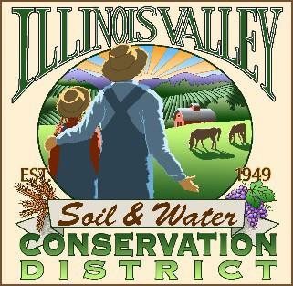
Illinois Valley Soil and Water Conservation District
331 E Cottage Park Dr Suite 1B - P.O. Box 352
Cave Junction, OR 97523 Phone: 541-592-3731

Monthly Meeting Agenda May 22, 2025- IVSWCD Office/ZOOM
IVSWCD is inviting you to a scheduled Zoom meeting.
Topic: Illinois Valley Soil & Water Conservation District Meeting
Time: April 24, 2025 - 6:00 pm Join Zoom Meeting:
https://us06web.zoom.us/j/95435099861?pwd=UXNsUEgyT200Ym9ZUVhEa1UvbnFUdz09
Meeting ID: 954 3509 9861
Passcode: Conserve
- 6:00 PM: Call to Order
- 6:01 PM: Acceptance of Minutes
- 6:05 PM: Acceptance of Financial Reports
- 6:10 PM: Old Business
a. Bio-Char Kilns
- 6:15 PM: New Business
  - Volunteer Weed Control
6:30 PM: Staff and Partnering Agency Reports
  - John’s report
  - Arlyse’s Report
  - Partnering Agency Reports
- 7:00 Public comments
- 7:15 Adjournment

