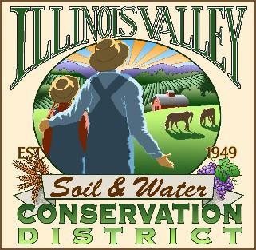
Illinois Valley Soil and Water Conservation District
331 E Cottage Park Dr Suite 1B - P.O. Box 352
Cave Junction, OR 97523 Phone: 541-592-3731

Monthly Board Meeting Agenda December 19, 2024- SWCD Office/ZOOM

- 6:00 PM: Call to Order
- 6:01 PM: Acceptance of Minutes
- 6:05 PM: Acceptance of Financial Reports
- 6:08 PM: Old Business
  - Intergovernmental Agreement with Two Rivers SWCD
  - MOU with Community Wildfire Resiliency Coalition

- 6:18 PM: New Business
  - At-Large 2 appointment- Discussion/Action
  - Resolution for Annual Meeting
6:25 PM: Staff and Partnering Agency Reports
  - John’s report
  - Arlyse’s Report
  - Partnering Agency Reports
- 6:30 PM Public comments
- 6:31 PM: Adjourn to Holiday Party


